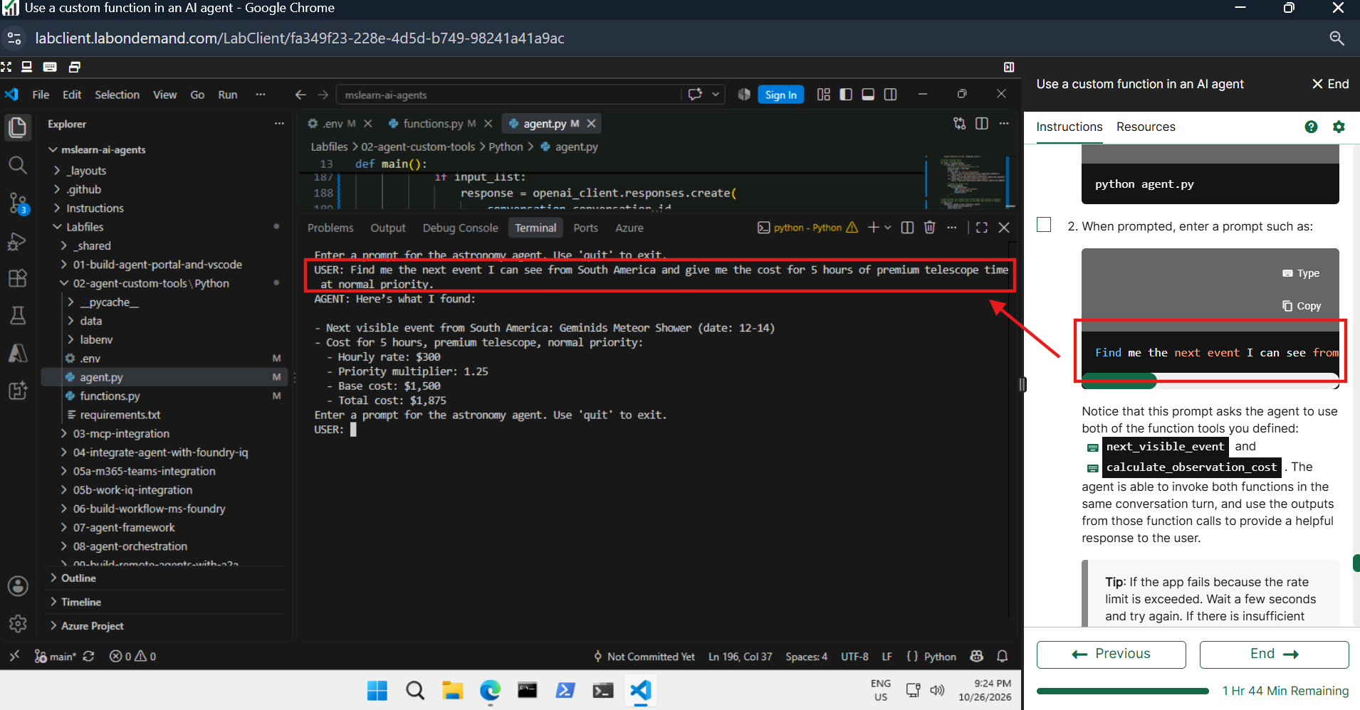

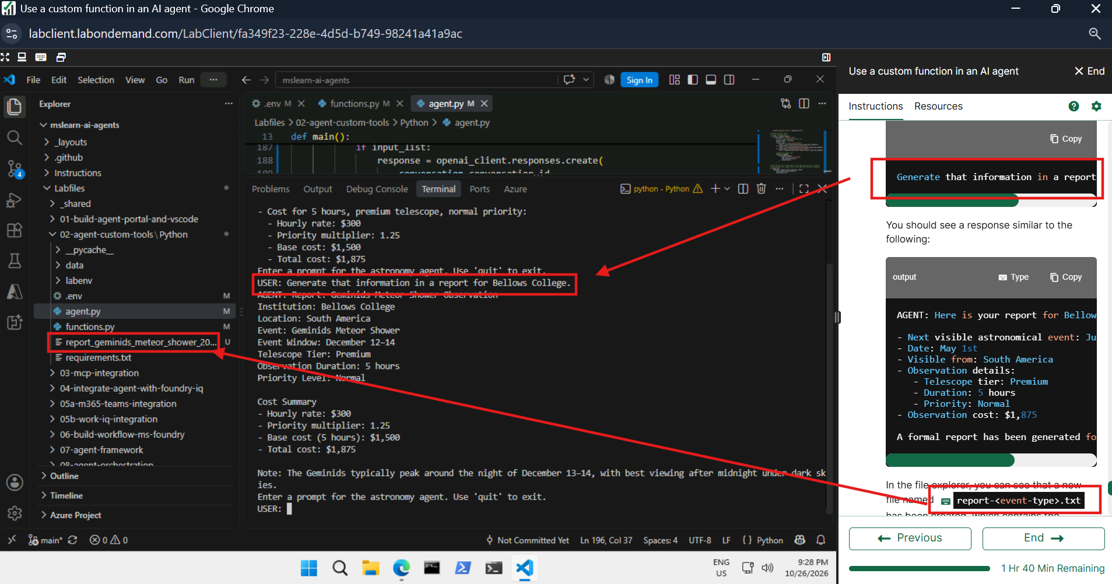

Function .py
import json
from datetime import datetime

def _load_events(file_path: str = "data/events.txt") -> list:
events = []
with open(file_path) as f:
for line in f:
parts = line.strip().split("|")
if len(parts) == 4:
month, day = map(int, parts[2].split("-"))
events.append((
parts[0], # name
parts[1], # type
month * 100 + day, # sortable month-day int
parts[2], # month-day string
set(parts[3].split(";")), # locations as a set
))
events.sort(key=lambda e: e[2])
return events

def _load_rates(file_path: str) -> dict:
rates = {}
with open(file_path) as f:
for line in f:
parts = line.strip().split("|")
if len(parts) == 2:
rates[parts[0]] = float(parts[1])
return rates

EVENTS = _load_events()
TELESCOPE_RATES = _load_rates("data/telescope_rates.txt")
PRIORITY_MULTIPLIERS = _load_rates("data/priority_multipliers.txt")

# Determine the next visible astronomical event for a given location
# Determine the next visible astronomical event for a given location
def next_visible_event(location: str) -> str:
"""Returns the next visible astronomical event for a location."""
today = int(datetime.now().strftime("%m%d"))
loc = location.lower().replace(" ", "_")

# Retrieve the next event visible from the location, starting with events later this year
for name, event_type, date, date_str, locs in EVENTS:
if loc in locs and date >= today:
return json.dumps({"event": name, "type": event_type, "date": date_str, "visible_from": sorted(locs)})

return json.dumps({"message": f"No upcoming events found for {location}."})

# Calculate the cost of telescope observation time based on the tier, hours, and priority
def calculate_observation_cost(telescope_tier: str, hours: float, priority: str) -> str:
"""Calculates the cost of telescope observation time."""
tier = telescope_tier.lower()
pri = priority.lower()

if tier not in TELESCOPE_RATES:
return json.dumps({"error": f"Unknown telescope tier '{telescope_tier}'. Choose from: {', '.join(TELESCOPE_RATES)}"})

if pri not in PRIORITY_MULTIPLIERS:
return json.dumps({"error": f"Unknown priority '{priority}'. Choose from: {', '.join(PRIORITY_MULTIPLIERS)}"})

if hours <= 0:
return json.dumps({"error": "Hours must be greater than zero."})

base_cost = TELESCOPE_RATES[tier] * hours
multiplier = PRIORITY_MULTIPLIERS[pri]
total_cost = base_cost * multiplier

return json.dumps({
"telescope_tier": tier,
"hours": hours,
"hourly_rate": TELESCOPE_RATES[tier],
"priority": pri,
"priority_multiplier": multiplier,
"base_cost": base_cost,
"total_cost": total_cost
})

# Generate an observation report summarizing the details of an astronomical observation session
def generate_observation_report(event_name: str, location: str, telescope_tier: str, hours: float, priority: str, observer_name: str) -> str:
"""
Generates an observation session report and saves it to a file.

Returns:
JSON string with the file path of the generated report.
"""
cost_result = json.loads(calculate_observation_cost(telescope_tier, hours, priority))
event_result = json.loads(next_visible_event(location))

if "error" in cost_result:
return json.dumps(cost_result)

timestamp = datetime.now().strftime("%Y-%m-%d %H:%M")
filename = f"report_{event_name.replace(' ', '_').lower()}_{timestamp.replace(':', '').replace(' ', '_')}.txt"

report = f"""======================================
CONTOSO OBSERVATORIES - SESSION REPORT
======================================
Date: {timestamp}
Observer: {observer_name}
Event: {event_name}
Location: {location}

NEXT VISIBLE EVENT
Event: {event_result.get('event', 'N/A')}
Date: {event_result.get('date', 'N/A')}

TELESCOPE BOOKING
Tier: {cost_result['telescope_tier']}
Hours: {cost_result['hours']}
Hourly Rate: ${cost_result['hourly_rate']:.2f}
Priority: {cost_result['priority']}
Multiplier: {cost_result['priority_multiplier']}x

COST SUMMARY
Base Cost: ${cost_result['base_cost']:.2f}
Total Cost: ${cost_result['total_cost']:.2f}
======================================
"""

with open(filename, "w") as f:
f.write(report)

return json.dumps({"status": "Report generated", "file": filename})

Agent.py
import os
import json
from dotenv import load_dotenv

# Add references
# Add references
from azure.ai.projects import AIProjectClient
from azure.identity import DefaultAzureCredential
from azure.ai.projects.models import PromptAgentDefinition, FunctionTool
from openai.types.responses.response_input_param import FunctionCallOutput, ResponseInputParam
from functions import next_visible_event, calculate_observation_cost, generate_observation_report

def main():
# Clear the console
os.system('cls' if os.name=='nt' else 'clear')

# Load environment variables from .env file
load_dotenv()
project_endpoint = os.getenv("PROJECT_ENDPOINT")
model_deployment = os.getenv("MODEL_DEPLOYMENT_NAME")

# Connect to the project client
# Connect to the project client
with (
DefaultAzureCredential() as credential,
AIProjectClient(endpoint=project_endpoint, credential=credential) as project_client,
project_client.get_openai_client() as openai_client,
):

# Define the event function tool
# Define the event function tool
event_tool = FunctionTool(
name="next_visible_event",
description="Get the next visible event in a given location.",
parameters={
"type": "object",
"properties": {
"location": {
"type": "string",
"description": "continent to find the next visible event in (e.g. 'north_america', 'south_america', 'australia')",
},
},
"required": ["location"],
"additionalProperties": False,
},
strict=True,
)

# Define the observation cost function tool
# Define the observation cost function tool
cost_tool = FunctionTool(
name="calculate_observation_cost",
description="Calculate the cost of an observation based on the telescope tier, number of hours, and priority level.",
parameters={
"type": "object",
"properties": {
"telescope_tier": {
"type": "string",
"description": "the tier of the telescope (e.g. 'standard', 'advanced', 'premium')",
},
"hours": {
"type": "number",
"description": "the number of hours for the observation",
},
"priority": {
"type": "string",
"description": "the priority level of the observation (e.g. 'low', 'normal', 'high')",
},
},
"required": ["telescope_tier", "hours", "priority"],
"additionalProperties": False,
},
strict=True,
)

# Define the observation report generation function tool
# Define the observation report generation function tool
report_tool = FunctionTool(
name="generate_observation_report",
description="Generate a report summarizing an astronomical observation",
parameters={
"type": "object",
"properties": {
"event_name": {
"type": "string",
"description": "the name of the astronomical event being observed",
},
"location": {
"type": "string",
"description": "the location of the observer",
},
"telescope_tier": {
"type": "string",
"description": "the tier of the telescope used for the observation (e.g. 'standard', 'advanced', 'premium')",
},
"hours": {
"type": "number",
"description": "the number of hours the telescope was used for the observation",
},
"priority": {
"type": "string",
"description": "the priority level of the observation (e.g. 'low', 'normal', 'high')",
},
"observer_name": {
"type": "string",
"description": "the name of the person who conducted the observation",
},
},
"required": ["event_name", "location", "telescope_tier", "hours", "priority", "observer_name"],
"additionalProperties": False,
},
strict=True,
)

# Create a new agent with the function tools
# Create a new agent with the function tools
agent = project_client.agents.create_version(
agent_name="astronomy-agent",
definition=PromptAgentDefinition(
model=model_deployment,
instructions=
"""You are an astronomy observations assistant that helps users find
information about astronomical events and calculate telescope rental costs.
Use the available tools to assist users with their inquiries.""",
tools=[event_tool, cost_tool, report_tool],
),
)

# Create a thread for the chat session
# Create a thread for the chat session
conversation = openai_client.conversations.create()

while True:
user_input = input("Enter a prompt for the astronomy agent. Use 'quit' to exit.\nUSER: ").strip()
if user_input.lower() == "quit":
print("Exiting chat.")
break

# Create a list to hold function call outputs that will be sent back as input to the agent
# Create a list to hold function call outputs that will be sent back as input to the agent
input_list: ResponseInputParam = []

# Send a prompt to the agent
# Send a prompt to the agent
openai_client.conversations.items.create(
conversation_id=conversation.id,
items=[{"type": "message", "role": "user", "content": user_input}],
)

# Retrieve the agent's response, which may include function calls
# Retrieve the agent's response, which may include function calls
response = openai_client.responses.create(
conversation=conversation.id,
extra_body={"agent_reference": {"name": agent.name, "type": "agent_reference"}},
input=input_list,
)

# Check the run status for failures
if response.status == "failed":
print(f"Response failed: {response.error}")

# Process function calls
# Process function calls
for item in response.output:
if item.type == "function_call":
# Retrieve the matching function tool
function_name = item.name
result = None
if item.name == "next_visible_event":
result = next_visible_event(**json.loads(item.arguments))
elif item.name == "calculate_observation_cost":
result = calculate_observation_cost(**json.loads(item.arguments))
elif item.name == "generate_observation_report":
result = generate_observation_report(**json.loads(item.arguments))

# Append the output text
input_list.append(
FunctionCallOutput(
type="function_call_output",
call_id=item.call_id,
output=result,
)
)

# Send function call outputs back to the model and retrieve a response
# Send function call outputs back to the model and retrieve a response
if input_list:
response = openai_client.responses.create(
conversation=conversation.id,
input=input_list,
extra_body={"agent_reference": {"name": agent.name, "type": "agent_reference"}},
)
# Display the agent's response
print(f"AGENT: {response.output_text}")

# Delete the agent when done
# Delete the agent when done
project_client.agents.delete_version(agent_name=agent.name, agent_version=agent.version)
print("Deleted agent.")

if __name__ == '__main__':
main()

